**University of North Texas**



**Corporate Expense Management & Approval System**

**Members:  
Sathwika Karingu -11708107  
Shreenath Jinaga-11752833  
Ashwitha Kollapieni-11714415  
Spoorthi Hassan-11814524  
Sri Ramya Katukuri- 11788716**

**Table Of Contents**

1. General Description – Objectives and Scope 3

2. Specific User Requirements 3

3. Business Rules 3

5. Data Dictionary 4

6. Queries And Operations 5

a) Creation Queries 5

i. Department Table 5

ii. Employee Table 5

iii. Expense Report table 6

iv. Vendor Table 6

v. ExpenseItem Table 6

vi. Approver table 6

vii. ApprovalLog Table 6

viii. Payment Table 6

b) Insertion Queries 7

i. Department Table 7

ii. Employee Table 7

iii. Expense Report table 7

iv. Vendor Table 8

v. ExpenseItem Table 8

vi. Approver table 9

vii. ApprovalLog Table 9

viii. Payment Table 10

7. Data Retrieval 10

a) Query 1: Pending or Rejected Reports with Comments from Approvers 10

b) Query 2: Total Approved Reimbursements Paid by Department 11

c) Query 3: Detailed Breakdown of Expense Items by Report 12

d) Query 4: Approver-wise Report Actions 12

e) Query 5: Employee-wise Summary of Expense Reports and Payment Status 13

8.Conclusion…………………………………………………………………………………………………………………………………………………….18

9.References……………………………………………………………………………………………………………………………………………………18

1. **General Description – Objectives and Scope**

**1.1 Description**

The proposed database system is for managing and streamlining the corporate expense approval and tracking workflow. This system can be used by organizations to handle the expenses claimed by employees, track department-wise budgets, monitor payment distributions and further enforce hierarchical approval mechanisms. This could function at the department level and help integrate the expense data with accounting and budgeting systems for quarterly or monthly reporting as required. The aim to reduce the manual work, improve the transparency and prevent any over-budget of the any department through audit trails.

**1.2 Objectives**

* **Expense Submission Automation:** The system ensures expense submission through automation that permits staff to validate account reports using digital receipts under defined categories.
* **Multi-Level Approval Workflow:** The workflow includes three approval steps with Team Leads together with Finance Managers and Directors whom must validate expenses by company policies as well as claim values.
* **Departmental Budget Monitoring:** Departmental Budget Monitoring enables users to monitor expenses at the departmental level alongside quarterly or annual budget allocations for budget control purposes.
* **Vendor Management:** The system allows users to connect expense items with vendors in order to analyze procurement activities by monitoring regular supplier relationships.
* **Approval Audit Trails:** An approval audit trail system should maintain detailed records which show all approval decisions along with user names and time stamps and written explanations and these logs serve both internal audit needs and compliance checks.
* **Payment Processing Integration:** The system discloses payment records through payment processing integration after complete approval which confirms authorized financial distributions.
* **Role-Based Access Control:** The implementation of Role-Based Access Control allows administrators to establish access privileges according to employee roles such as Employees and Approvers and Administrators which increases system security together with accountability.
* **Real-Time Claim Tracking:** Provide employees and approvers with real-time visibility into the status of submitted reports, approvals, rejections, and payments.
* **Reporting and Analytics:** The system provides analytical capabilities that deliver reports regarding employee reimbursement data in addition to breakdowns of approvals alongside department spending trends and vendor utilization statistics for strategic planning.
* **Support for Diverse Expense Categories:** The system should handle a broad variety of expense groups including travel expenses combined with food costs and lodging needs and IT acquisition and remote working assistance costs.

**1.3 Scope**

The Corporate Expense Management and Approval System functions to automate the complete process of handling employee expenses across the organization. Through the automated system employees can present expense claims which cover travel expenses along with accommodation costs and meals along with office supplies and remote work reimbursement. The system enables the financial organization to apply multi-level workflow approvals which follow their established financial policies leading to expense review at various management levels prior to reimbursement. The system enables department managers to track expenses because it automatically compares spending amounts with quarterly budget allocations. The system allows vendor tracking of expense claim purchases along with real-time report updated status throughout its lifecycle. The platform delivers services to Finance along with HR and Administrative teams and Departmental Operations teams which result in improved transparency as well as financial control and operational efficiency combined with auditability for corporate settings.

1. **Specific User Requirements**

* Employees may submit elaborated expense reports containing various purchase items and should include necessary documentation.
* Managers gain access to approve or deny department expenses submitted by employees according to the assigned budgets.
* Multiple levels of approval can be included. (e.g., Team Lead → Finance Dept → Director).
* The system enables users to track several expense categories which include all types of business outlays such as hotel accommodation and food purchased on business travels in addition to supplying office materials along with home-office charges regarding internet access.
* Budgets are monitored and tracked at a department level and compared against actual expenses.
* Payment records are stored for approved expenses.
* Admins can view audit reports of all approval actions.
* Vendors used in reported purchases can be tracked.
* Role-based access control to restrict who can approve, submit, and view.
* **Employees should be able to track the status of their claim in real time.**
* **Finance administrators should be able to generate quarterly expense summary reports specific to department and categories.**

1. **Business Rules**

* An employee can only submit expenses for themselves and must attach at least one receipt.
* Each expense report must include one or more categorized expense items.
* A manager can only approve expense reports from employees within their department.
* Expenses exceeding ₹10,000 require approval from the Finance Department and the Director.
* Department budgets are refreshed quarterly, and new expense entries cannot exceed the current budget.
* Payments are processed only after the final approval stage is completed.
* The same vendor can be linked to multiple expense items across different reports.
* Once an expense is rejected, it cannot be resubmitted; instead, a new report must be created.
* Admin users have access to all reports and logs but cannot submit expense reports.
* Only approved expenses are included in budget utilization metrics and audit reports.

1. **Entity-Relationship Diagram (ERD)**

1. **Data Dictionary**

| **Table Name** | **Field Name** | **Data Type** | **Description** | **Key** | **Constraints** |
| --- | --- | --- | --- | --- | --- |
| Department | DepartmentID | INT | Unique department identifier | Primary Key | Auto Increment, Not Null |
| Name | VARCHAR(100) | Department name |  | Not Null |
| BudgetAmount | DECIMAL(12,2) | Assigned budget |  | Not Null |
| BudgetPeriod | VARCHAR(50) | Budget cycle, e.g., Q1-2025 |  | Not Null |
| Employee | EmployeeID | INT | Unique employee identifier | Primary Key | Auto Increment, Not Null |
| Name | VARCHAR(100) | Employee's full name |  | Not Null |
| Email | VARCHAR(100) | Employee's email (unique) |  | Unique, Not Null |
| Role | VARCHAR(50) | Role (Employee/Admin) |  | Not Null |
| DepartmentID | INT | FK to Department | Foreign Key | Must exist in Department |
| ExpenseReport | ReportID | INT | Unique report identifier | Primary Key | Auto Increment, Not Null |
| EmployeeID | INT | FK to Employee | Foreign Key | Must exist in Employee |
| SubmittedDate | DATE | Date of submission |  | Not Null |
| TotalAmount | DECIMAL(12,2) | Total expense value |  | Not Null |
| Status | ENUM | Pending/Approved/Rejected |  | Default 'Pending' |
| ExpenseItem | ItemID | INT | Unique item ID | Primary Key | Auto Increment |
| ReportID | INT | FK to ExpenseReport | Foreign Key | Must exist in ExpenseReport |
| Category | VARCHAR(50) | Travel, Food, Supplies |  | Not Null |
| Description | VARCHAR(255) | Details of the expense |  | Optional |
| Amount | DECIMAL(10,2) | Cost of item |  | Not Null |
| VendorID | INT | FK to Vendor | Foreign Key | Optional |
| ReceiptLink | VARCHAR(255) | File path or URL to receipt |  | Optional |
| Vendor | VendorID | INT | Unique vendor ID | Primary Key | Auto Increment |
| Name | VARCHAR(100) | Vendor name |  | Not Null |
| Category | VARCHAR(50) | Vendor type/category |  | Optional |
| ContactEmail | VARCHAR(100) | Contact email |  | Optional |
| Approver | ApproverID | INT | Unique approver ID | Primary Key | Auto Increment |
| Name | VARCHAR(100) | Approver's name |  | Not Null |
| Email | VARCHAR(100) | Email (unique) |  | Unique, Not Null |
| Role | VARCHAR(50) | Manager/Finance/Director |  | Not Null |
| Level | INT | Hierarchy level |  | Not Null |
| ApprovalLog | ApprovalID | INT | Approval log ID | Primary Key | Auto Increment |
| ReportID | INT | FK to ExpenseReport | Foreign Key | Must exist in ExpenseReport |
| ApproverID | INT | FK to Approver | Foreign Key | Must exist in Approver |
| Action | ENUM | Approved/Rejected |  | Not Null |
| Timestamp | TIMESTAMP | Date & time of action |  | Default CURRENT_TIMESTAMP |
| Comments | TEXT | Remarks if any |  | Optional |
| Payment | PaymentID | INT | Unique payment ID | Primary Key | Auto Increment |
| ReportID | INT | FK to ExpenseReport | Foreign Key | Must be approved report |
| AmountPaid | DECIMAL(12,2) | Paid amount |  | Not Null |
| PaymentDate | DATE | Payment date |  | Not Null |
| PaymentMethod | VARCHAR(50) | e.g., Card, Bank Transfer |  | Optional |
| Status | ENUM | Pending/Completed |  | Default 'Pending' |

1. **Queries And Operations**
   1. **Creation Queries**
      1. Department Table

CREATE TABLE Department (

DepartmentID INT AUTO_INCREMENT PRIMARY KEY,

Name VARCHAR(100) NOT NULL,

BudgetAmount DECIMAL(12,2) NOT NULL,

BudgetPeriod VARCHAR(50) NOT NULL

);

* + 1. Employee Table

CREATE TABLE Employee (

EmployeeID INT AUTO_INCREMENT PRIMARY KEY,

Name VARCHAR(100) NOT NULL,

Email VARCHAR(100) UNIQUE NOT NULL,

Role VARCHAR(50) NOT NULL, -- e.g., Employee, Admin

DepartmentID INT NOT NULL,

FOREIGN KEY (DepartmentID) REFERENCES Department(DepartmentID)

);

* + 1. Expense Report table

CREATE TABLE ExpenseReport (

ReportID INT AUTO_INCREMENT PRIMARY KEY,

EmployeeID INT NOT NULL,

SubmittedDate DATE NOT NULL,

TotalAmount DECIMAL(12,2) NOT NULL,

Status ENUM('Pending', 'Approved', 'Rejected') DEFAULT 'Pending',

FOREIGN KEY (EmployeeID) REFERENCES Employee(EmployeeID)

);

* + 1. Vendor Table

CREATE TABLE Vendor (

VendorID INT AUTO_INCREMENT PRIMARY KEY,

Name VARCHAR(100) NOT NULL,

Category VARCHAR(50), -- e.g., Travel, Supplies, Food, etc.

ContactEmail VARCHAR(100)

);

* + 1. ExpenseItem Table

CREATE TABLE ExpenseItem (

ItemID INT AUTO_INCREMENT PRIMARY KEY,

ReportID INT NOT NULL,

Category VARCHAR(50) NOT NULL,

Description VARCHAR(255),

Amount DECIMAL(10,2) NOT NULL,

VendorID INT,

ReceiptLink VARCHAR(255),

FOREIGN KEY (ReportID) REFERENCES ExpenseReport(ReportID),

FOREIGN KEY (VendorID) REFERENCES Vendor(VendorID)

);

* + 1. Approver table

CREATE TABLE Approver (

ApproverID INT AUTO_INCREMENT PRIMARY KEY,

Name VARCHAR(100) NOT NULL,

Email VARCHAR(100) UNIQUE NOT NULL,

Role VARCHAR(50) NOT NULL, -- e.g., Manager, Finance, Director

Level INT NOT NULL -- e.g., 1 = Manager, 2 = Finance, 3 = Director

);

* + 1. ApprovalLog Table

CREATE TABLE ApprovalLog (

ApprovalID INT AUTO_INCREMENT PRIMARY KEY,

ReportID INT NOT NULL,

ApproverID INT NOT NULL,

Action ENUM('Approved', 'Rejected') NOT NULL,

Timestamp TIMESTAMP DEFAULT CURRENT_TIMESTAMP,

Comments TEXT,

FOREIGN KEY (ReportID) REFERENCES ExpenseReport(ReportID),

FOREIGN KEY (ApproverID) REFERENCES Approver(ApproverID)

);

* + 1. Payment Table

CREATE TABLE Payment (

PaymentID INT AUTO_INCREMENT PRIMARY KEY,

ReportID INT NOT NULL,

AmountPaid DECIMAL(12,2) NOT NULL,

PaymentDate DATE NOT NULL,

PaymentMethod VARCHAR(50), -- e.g., Bank Transfer, Card, Reimbursement

Status ENUM('Pending', 'Completed') DEFAULT 'Pending',

FOREIGN KEY (ReportID) REFERENCES ExpenseReport(ReportID)

);

**Result and Screenshot:**

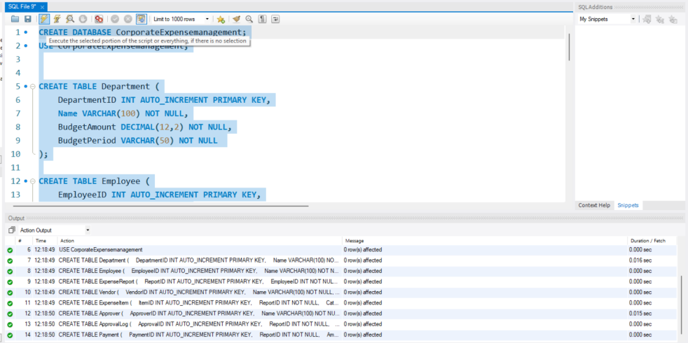

(Fig 2)

* 1. **Insertion Queries**
     1. Department Table

INSERT INTO Department (DepartmentID, Name, BudgetAmount, BudgetPeriod) VALUES

(1, 'Finance', 100000.0, 'Q1-2025'),

(2, 'IT', 150000.0, 'Q1-2025'),

(3, 'HR', 80000.0, 'Q1-2025'),

(4, 'Operations', 120000.0, 'Q1-2025'),

(5, 'Marketing', 110000.0, 'Q1-2025');

* + 1. Employee Table

INSERT INTO Employee (EmployeeID, Name, Email, Role, DepartmentID) VALUES

(1, 'Aarav Sharma', 'employee1@example.com', 'Employee', 4),

(2, 'Meera Iyer', 'employee2@example.com', 'Employee', 5),

(3, 'Rohan Mehta', 'employee3@example.com', 'Employee', 2),

(4, 'Nisha Kulkarni', 'employee4@example.com', 'Employee', 3),

(5, 'Arjun Reddy', 'employee5@example.com', 'Employee', 1),

(6, 'Emily Thomas', 'employee6@example.com', 'Employee', 1),

(7, 'Kunal Malhotra', 'employee7@example.com', 'Employee', 2),

(8, 'Sneha Joshi', 'employee8@example.com', 'Employee', 5),

(9, 'Aditya Verma', 'employee9@example.com', 'Employee', 1),

(10, 'Rachel Mathews', 'employee10@example.com', 'Employee', 4),

(11, 'Rahul Kapoor', 'employee11@example.com', 'Employee', 5),

(12, 'Aishwarya Rao', 'employee12@example.com', 'Employee', 2),

(13, 'Siddharth Jain', 'employee13@example.com', 'Employee', 1),

(14, 'Neha Bhatt', 'employee14@example.com', 'Employee', 4),

(15, 'Vishal Bansal', 'employee15@example.com', 'Employee', 1),

(16, 'Grace Fernandes', 'employee16@example.com', 'Employee', 4),

(17, 'Manav Thakur', 'employee17@example.com', 'Employee', 3),

(18, 'Riya Mukherjee', 'employee18@example.com', 'Employee', 2),

(19, 'Harsh Patel', 'employee19@example.com', 'Employee', 2),

(20, 'Kavya Sinha', 'employee20@example.com', 'Employee', 1),

(21, 'James Samuel', 'employee21@example.com', 'Employee', 2),

(22, 'Ishita Ghosh', 'employee22@example.com', 'Employee', 4),

(23, 'Varun Das', 'employee23@example.com', 'Employee', 5),

(24, 'Pooja Pillai', 'employee24@example.com', 'Employee', 3),

(25, 'Yash Choudhury', 'employee25@example.com', 'Employee', 1);

* + 1. Expense Report table

INSERT INTO ExpenseReport (ReportID, EmployeeID, SubmittedDate, TotalAmount, Status) VALUES

(1, 1, '2025-04-12', 4211.33, 'Rejected'),

(2, 2, '2025-04-14', 1046.34, 'Approved'),

(3, 3, '2025-04-02', 1816.73, 'Approved'),

(4, 4, '2025-04-02', 2358.48, 'Approved'),

(5, 5, '2025-04-01', 4136.14, 'Approved'),

(6, 6, '2025-04-15', 1588.24, 'Approved'),

(7, 7, '2025-04-09', 3430.7, 'Rejected'),

(8, 8, '2025-04-02', 1422.42, 'Rejected'),

(9, 9, '2025-04-09', 4596.68, 'Approved'),

(10, 10, '2025-04-11', 3283.9, 'Approved'),

(11, 11, '2025-04-07', 2615.7, 'Approved'),

(12, 12, '2025-04-08', 2688.75, 'Approved'),

(13, 13, '2025-04-11', 4158.41, 'Rejected'),

(14, 14, '2025-04-01', 4455.11, 'Approved'),

(15, 15, '2025-04-01', 4552.17, 'Rejected'),

(16, 16, '2025-04-14', 4649.97, 'Approved'),

(17, 17, '2025-04-12', 1774.69, 'Approved'),

(18, 18, '2025-04-12', 3489.81, 'Approved'),

(19, 19, '2025-04-08', 2729.64, 'Rejected'),

(20, 20, '2025-04-03', 4119.97, 'Approved'),

(21, 21, '2025-04-07', 1734.73, 'Approved'),

(22, 22, '2025-04-12', 4359.2, 'Rejected'),

(23, 23, '2025-04-09', 2678.55, 'Approved'),

(24, 24, '2025-04-08', 3969.84, 'Approved'),

(25, 25, '2025-04-01', 2081.14, 'Rejected');

* + 1. Vendor Table

INSERT INTO Vendor (VendorID, Name, Category, ContactEmail) VALUES

(1, 'TravelPro', 'Travel', 'travelpro@example.com'),

(2, 'Staples', 'Office Supplies', 'staples@example.com'),

(3, 'Zomato', 'Food', 'zomato@example.com'),

(4, 'Airtel', 'Internet', 'airtel@example.com'),

(5, 'OYO', 'Accommodation', 'oyo@example.com');

* + 1. ExpenseItem Table

INSERT INTO ExpenseItem (ItemID, ReportID, Category, Description, Amount, VendorID, ReceiptLink) VALUES

(1, 23, 'Food', 'Food expense submitted for approval', 383.58, 3, '/receipts/1.pdf'),

(2, 21, 'Travel', 'Travel expense submitted for approval', 586.12, 2, '/receipts/2.pdf'),

(3, 8, 'Internet', 'Internet expense submitted for approval', 158.64, 1, '/receipts/3.pdf'),

(4, 18, 'Travel', 'Travel expense submitted for approval', 335.01, 5, '/receipts/4.pdf'),

(5, 15, 'Accommodation', 'Accommodation expense submitted for approval', 171.74, 2, '/receipts/5.pdf'),

(6, 5, 'Travel', 'Travel expense submitted for approval', 948.33, 2, '/receipts/6.pdf'),

(7, 6, 'Internet', 'Internet expense submitted for approval', 420.76, 4, '/receipts/7.pdf'),

(8, 12, 'Office Supplies', 'Office Supplies expense submitted for approval', 587.55, 5, '/receipts/8.pdf'),

(9, 12, 'Food', 'Food expense submitted for approval', 701.54, 3, '/receipts/9.pdf'),

(10, 23, 'Food', 'Food expense submitted for approval', 848.28, 2, '/receipts/10.pdf'),

(11, 21, 'Food', 'Food expense submitted for approval', 335.95, 4, '/receipts/11.pdf'),

(12, 14, 'Food', 'Food expense submitted for approval', 566.1, 5, '/receipts/12.pdf'),

(13, 11, 'Office Supplies', 'Office Supplies expense submitted for approval', 390.47, 3, '/receipts/13.pdf'),

(14, 25, 'Travel', 'Travel expense submitted for approval', 738.75, 1, '/receipts/14.pdf'),

(15, 21, 'Travel', 'Travel expense submitted for approval', 558.54, 5, '/receipts/15.pdf'),

(16, 4, 'Accommodation', 'Accommodation expense submitted for approval', 721.91, 4, '/receipts/16.pdf'),

(17, 17, 'Office Supplies', 'Office Supplies expense submitted for approval', 499.9, 4, '/receipts/17.pdf'),

(18, 3, 'Accommodation', 'Accommodation expense submitted for approval', 402.32, 2, '/receipts/18.pdf'),

(19, 19, 'Food', 'Food expense submitted for approval', 450.13, 1, '/receipts/19.pdf'),

(20, 1, 'Office Supplies', 'Office Supplies expense submitted for approval', 985.35, 2, '/receipts/20.pdf'),

(21, 18, 'Office Supplies', 'Office Supplies expense submitted for approval', 106.36, 1, '/receipts/21.pdf'),

(22, 10, 'Office Supplies', 'Office Supplies expense submitted for approval', 149.37, 5, '/receipts/22.pdf'),

(23, 3, 'Food', 'Food expense submitted for approval', 190.23, 3, '/receipts/23.pdf'),

(24, 6, 'Accommodation', 'Accommodation expense submitted for approval', 261.61, 3, '/receipts/24.pdf'),

(25, 13, 'Accommodation', 'Accommodation expense submitted for approval', 374.22, 5, '/receipts/25.pdf'),

(26, 2, 'Internet', 'Internet expense submitted for approval', 975.43, 5, '/receipts/26.pdf'),

(27, 1, 'Travel', 'Travel expense submitted for approval', 155.38, 1, '/receipts/27.pdf'),

(28, 4, 'Food', 'Food expense submitted for approval', 136.69, 4, '/receipts/28.pdf'),

(29, 13, 'Internet', 'Internet expense submitted for approval', 522.85, 2, '/receipts/29.pdf'),

(30, 11, 'Office Supplies', 'Office Supplies expense submitted for approval', 151.26, 1, '/receipts/30.pdf'),

(31, 11, 'Internet', 'Internet expense submitted for approval', 831.03, 4, '/receipts/31.pdf'),

(32, 12, 'Internet', 'Internet expense submitted for approval', 672.97, 5, '/receipts/32.pdf'),

(33, 18, 'Travel', 'Travel expense submitted for approval', 753.09, 2, '/receipts/33.pdf'),

(34, 3, 'Food', 'Food expense submitted for approval', 731.63, 1, '/receipts/34.pdf'),

(35, 20, 'Travel', 'Travel expense submitted for approval', 304.87, 3, '/receipts/35.pdf'),

(36, 17, 'Office Supplies', 'Office Supplies expense submitted for approval', 765.21, 5, '/receipts/36.pdf'),

(37, 9, 'Travel', 'Travel expense submitted for approval', 466.37, 5, '/receipts/37.pdf'),

(38, 21, 'Travel', 'Travel expense submitted for approval', 292.93, 2, '/receipts/38.pdf'),

(39, 25, 'Food', 'Food expense submitted for approval', 498.7, 3, '/receipts/39.pdf'),

(40, 6, 'Internet', 'Internet expense submitted for approval', 538.96, 3, '/receipts/40.pdf'),

(41, 3, 'Office Supplies', 'Office Supplies expense submitted for approval', 609.07, 1, '/receipts/41.pdf'),

(42, 10, 'Internet', 'Internet expense submitted for approval', 861.54, 2, '/receipts/42.pdf'),

(43, 13, 'Travel', 'Travel expense submitted for approval', 446.08, 2, '/receipts/43.pdf'),

(44, 7, 'Office Supplies', 'Office Supplies expense submitted for approval', 582.26, 2, '/receipts/44.pdf'),

(45, 5, 'Internet', 'Internet expense submitted for approval', 285.43, 4, '/receipts/45.pdf'),

(46, 23, 'Food', 'Food expense submitted for approval', 951.69, 4, '/receipts/46.pdf'),

(47, 25, 'Travel', 'Travel expense submitted for approval', 803.96, 2, '/receipts/47.pdf'),

(48, 25, 'Food', 'Food expense submitted for approval', 107.25, 5, '/receipts/48.pdf'),

(49, 17, 'Accommodation', 'Accommodation expense submitted for approval', 662.39, 1, '/receipts/49.pdf'),

(50, 20, 'Travel', 'Travel expense submitted for approval', 636.16, 4, '/receipts/50.pdf');

* + 1. Approver table

INSERT INTO Approver (ApproverID, Name, Email, Role, Level) VALUES

(1, 'John Manager', 'john.manager@example.com', 'Manager', 1),

(2, 'Alice Finance', 'alice.finance@example.com', 'Finance', 2),

(3, 'Bob Director', 'bob.director@example.com', 'Director', 3),

(4, 'Sarah Manager', 'sarah.manager@example.com', 'Manager', 1),

(5, 'Mike Finance', 'mike.finance@example.com', 'Finance', 2);

* + 1. ApprovalLog Table

INSERT INTO ApprovalLog (ApprovalID, ReportID, ApproverID, Action, Comments) VALUES

(1, 1, 5, 'Rejected', 'Exceeded department budget limit'),

(2, 2, 3, 'Approved', 'All clear'),

(3, 3, 5, 'Approved', 'All clear'),

(4, 4, 1, 'Approved', 'All clear'),

(5, 5, 1, 'Approved', 'All clear'),

(6, 6, 4, 'Approved', 'All clear'),

(7, 7, 2, 'Rejected', 'Exceeded department budget limit'),

(8, 8, 5, 'Rejected', 'Missing required receipts'),

(9, 9, 1, 'Approved', 'All clear'),

(10, 10, 1, 'Approved', 'All clear'),

(11, 11, 5, 'Approved', 'All clear'),

(12, 12, 4, 'Approved', 'All clear'),

(13, 13, 5, 'Rejected', 'Exceeded department budget limit'),

(14, 14, 3, 'Approved', 'All clear'),

(15, 15, 5, 'Rejected', 'Missing required receipts'),

(16, 16, 3, 'Approved', 'All clear'),

(17, 17, 1, 'Approved', 'All clear'),

(18, 18, 1, 'Approved', 'All clear'),

(19, 19, 4, 'Rejected', 'Exceeded department budget limit'),

(20, 20, 4, 'Approved', 'All clear'),

(21, 21, 3, 'Approved', 'All clear'),

(22, 22, 2, 'Rejected', 'Missing required receipts'),

(23, 23, 3, 'Approved', 'All clear'),

(24, 24, 2, 'Approved', 'All clear'),

(25, 25, 4, 'Rejected', 'Exceeded department budget limit');

* + 1. Payment Table

INSERT INTO Payment (PaymentID, ReportID, AmountPaid, PaymentDate, PaymentMethod, Status) VALUES

(2, 2, 1046.34, '2025-04-27', 'Bank Transfer', 'Completed'),

(3, 3, 1816.73, '2025-04-30', 'Bank Transfer', 'Completed'),

(4, 4, 2358.48, '2025-04-21', 'Bank Transfer', 'Completed'),

(5, 5, 4136.14, '2025-04-22', 'Bank Transfer', 'Completed'),

(6, 6, 1588.24, '2025-04-30', 'Bank Transfer', 'Completed'),

(9, 9, 4596.68, '2025-04-27', 'Bank Transfer', 'Completed'),

(10, 10, 3283.9, '2025-04-30', 'Bank Transfer', 'Completed'),

(11, 11, 2615.7, '2025-04-20', 'Bank Transfer', 'Completed'),

(12, 12, 2688.75, '2025-04-22', 'Bank Transfer', 'Completed'),

(14, 14, 4455.11, '2025-04-17', 'Bank Transfer', 'Completed'),

(16, 16, 4649.97, '2025-04-20', 'Bank Transfer', 'Completed'),

(17, 17, 1774.69, '2025-04-16', 'Bank Transfer', 'Completed'),

(18, 18, 3489.81, '2025-04-27', 'Bank Transfer', 'Completed'),

(20, 20, 4119.97, '2025-04-22', 'Bank Transfer', 'Completed'),

(21, 21, 1734.73, '2025-04-16', 'Bank Transfer', 'Completed'),

(23, 23, 2678.55, '2025-04-22', 'Bank Transfer', 'Completed'),

(24, 24, 3969.84, '2025-04-26', 'Bank Transfer', 'Completed')

**Result and Screenshot:**

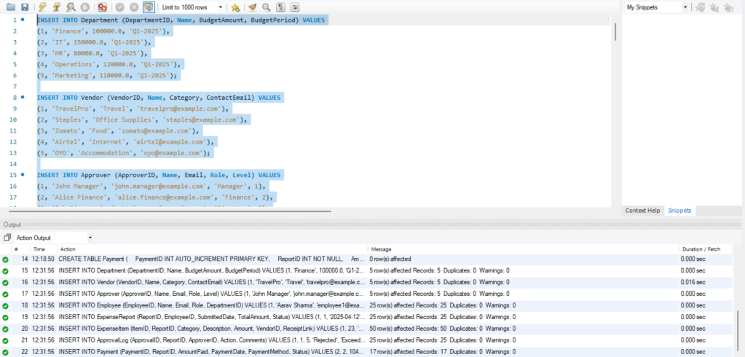

(Fig 3)

1. **Data Retrieval**
   1. ***Query 1: Pending or Rejected Reports with Comments from Approvers***

List all expense reports that are currently Pending or Rejected, along with the employee name, department, approver name, action taken, and approver comments.

***SQL Query :***

SELECT er.ReportID,

e.Name AS EmployeeName,

d.Name AS Department,

a.Name AS ApproverName,

al.Action,al.Comments FROM ExpenseReport er

JOIN Employee e ON er.EmployeeID = e.EmployeeID

JOIN Department d ON e.DepartmentID = d.DepartmentID

JOIN ApprovalLog al ON er.ReportID = al.ReportID

JOIN Approver a ON al.ApproverID = a.ApproverID

WHERE er.Status IN ('Pending', 'Rejected');

**Result and Screenshot:**

|  |  |  |  |  |  |
| --- | --- | --- | --- | --- | --- |
| ReportID | EmployeeName | Department | ApproverName | Action | Comments |
| 7 | Kunal Malhotra | IT | Alice Finance | Rejected | Exceeded department budget limit |
| 22 | Ishita Ghosh | Operations | Alice Finance | Rejected | Missing required receipts |
| 25 | Yash Choudhury | Finance | Sarah Manager | Rejected | Exceeded department budget limit |
| 19 | Harsh Patel | IT | Sarah Manager | Rejected | Exceeded department budget limit |
| 13 | Siddharth Jain | Finance | Mike Finance | Rejected | Exceeded department budget limit |
| 15 | Vishal Bansal | Finance | Mike Finance | Rejected | Missing required receipts |
| 1 | Aarav Sharma | Operations | Mike Finance | Rejected | Exceeded department budget limit |
| 8 | Sneha Joshi | Marketing | Mike Finance | Rejected | Missing required receipts |

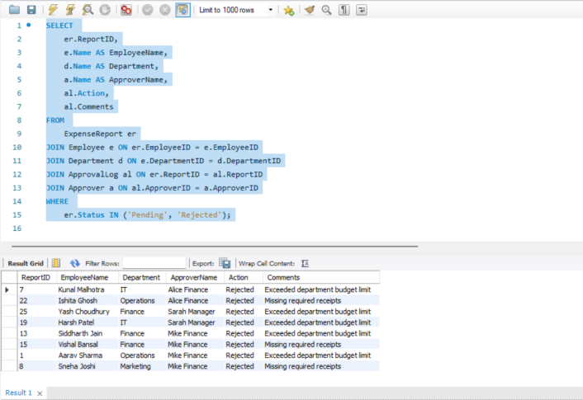

( Query 1 )

* 1. ***Query 2: Total Approved Reimbursements Paid by Department***

What is the total amount reimbursed per department for **approved** reports?

***SQL Query :***

SELECT d.Name AS Department,

SUM(p.AmountPaid) AS TotalReimbursed

FROM Payment p

JOIN ExpenseReport er ON p.ReportID = er.ReportID

JOIN Employee e ON er.EmployeeID = e.EmployeeID

JOIN Department d ON e.DepartmentID = d.DepartmentID

GROUP BY d.Name;

**Result and Screenshot:**

|  |  |
| --- | --- |
| Department | TotalReimbursed |
| Finance | 14441.03 |
| HR | 8103.01 |
| IT | 9730.02 |
| Marketing | 6340.59 |
| Operations | 12388.98 |

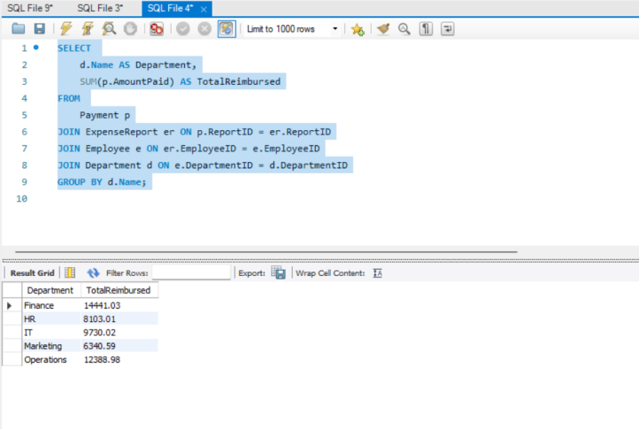

(Query 2 )

## **Query 3: Detailed Breakdown of Expense Items by Report**

For each report, show the submitted items including category, amount, and vendor name.

**SQL Query :**

SELECT ei.ReportID, ei.Category, ei.Amount, ei.Description,

v.Name AS VendorName

FROM ExpenseItem ei

LEFT JOIN Vendor v ON ei.VendorID = v.VendorID

ORDER BY ei.ReportID;

**Result and Screenshot:**

|  |  |  |  |  |
| --- | --- | --- | --- | --- |
| ReportID | Category | Amount | Description | VendorName |
| 1 | Office Supplies | 985.35 | Office Supplies expense submitted for approval | Staples |
| 1 | Travel | 155.38 | Travel expense submitted for approval | TravelPro |
| 2 | Internet | 975.43 | Internet expense submitted for approval | OYO |
| 3 | Food | 190.23 | Food expense submitted for approval | Zomato |
| 3 | Office Supplies | 609.07 | Office Supplies expense submitted for approval | TravelPro |
| 3 | Food | 731.63 | Food expense submitted for approval | TravelPro |
| 3 | Accommodation | 402.32 | Accommodation expense submitted for approval | Staples |
| 4 | Accommodation | 721.91 | Accommodation expense submitted for approval | Airtel |
| 4 | Food | 136.69 | Food expense submitted for approval | Airtel |
| 5 | Travel | 948.33 | Travel expense submitted for approval | Staples |
| 5 | Internet | 285.43 | Internet expense submitted for approval | Airtel |
| 6 | Accommodation | 261.61 | Accommodation expense submitted for approval | Zomato |
| 6 | Internet | 420.76 | Internet expense submitted for approval | Airtel |
| 6 | Internet | 538.96 | Internet expense submitted for approval | Zomato |
| 7 | Office Supplies | 582.26 | Office Supplies expense submitted for approval | Staples |
| 8 | Internet | 158.64 | Internet expense submitted for approval | TravelPro |
| 9 | Travel | 466.37 | Travel expense submitted for approval | OYO |
| 10 | Office Supplies | 149.37 | Office Supplies expense submitted for approval | OYO |
| 10 | Internet | 861.54 | Internet expense submitted for approval | Staples |
| 11 | Office Supplies | 390.47 | Office Supplies expense submitted for approval | Zomato |
| 11 | Office Supplies | 151.26 | Office Supplies expense submitted for approval | TravelPro |
| 11 | Internet | 831.03 | Internet expense submitted for approval | Airtel |
| 12 | Office Supplies | 587.55 | Office Supplies expense submitted for approval | OYO |
| 12 | Food | 701.54 | Food expense submitted for approval | Zomato |
| 12 | Internet | 672.97 | Internet expense submitted for approval | OYO |
| 13 | Internet | 522.85 | Internet expense submitted for approval | Staples |
| 13 | Accommodation | 374.22 | Accommodation expense submitted for approval | OYO |
| 13 | Travel | 446.08 | Travel expense submitted for approval | Staples |
| 14 | Food | 566.1 | Food expense submitted for approval | OYO |
| 15 | Accommodation | 171.74 | Accommodation expense submitted for approval | Staples |
| 17 | Office Supplies | 499.9 | Office Supplies expense submitted for approval | Airtel |
| 17 | Accommodation | 662.39 | Accommodation expense submitted for approval | TravelPro |
| 17 | Office Supplies | 765.21 | Office Supplies expense submitted for approval | OYO |
| 18 | Travel | 335.01 | Travel expense submitted for approval | OYO |
| 18 | Travel | 753.09 | Travel expense submitted for approval | Staples |
| 18 | Office Supplies | 106.36 | Office Supplies expense submitted for approval | TravelPro |
| 19 | Food | 450.13 | Food expense submitted for approval | TravelPro |
| 20 | Travel | 304.87 | Travel expense submitted for approval | Zomato |
| 20 | Travel | 636.16 | Travel expense submitted for approval | Airtel |
| 21 | Travel | 586.12 | Travel expense submitted for approval | Staples |
| 21 | Travel | 292.93 | Travel expense submitted for approval | Staples |
| 21 | Food | 335.95 | Food expense submitted for approval | Airtel |
| 21 | Travel | 558.54 | Travel expense submitted for approval | OYO |
| 23 | Food | 848.28 | Food expense submitted for approval | Staples |
| 23 | Food | 951.69 | Food expense submitted for approval | Airtel |
| 23 | Food | 383.58 | Food expense submitted for approval | Zomato |
| 25 | Travel | 738.75 | Travel expense submitted for approval | TravelPro |
| 25 | Travel | 803.96 | Travel expense submitted for approval | Staples |
| 25 | Food | 107.25 | Food expense submitted for approval | OYO |
| 25 | Food | 498.7 | Food expense submitted for approval | Zomato |

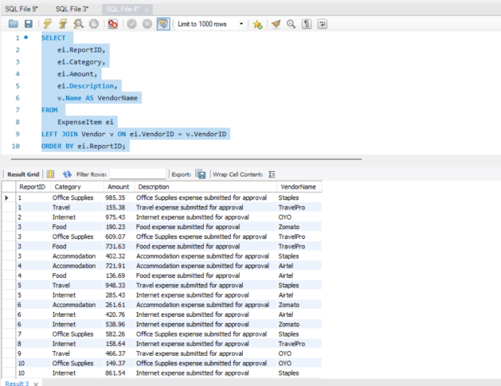

( Query 3 )

## **Query 4: Approver-wise Report Actions**

Which reports did each approver act on, and what were their decisions?

**SQL Query :**

SELECT a.Name AS ApproverName,

al.ReportID, al.Action, al.Timestamp, al.Comments

FROM ApprovalLog al

JOIN Approver a ON al.ApproverID = a.ApproverID

ORDER BY a.Name, al.Timestamp DESC;

**Result and Screenshot:**

|  |  |  |  |  |
| --- | --- | --- | --- | --- |
| ApproverName | ReportID | Action | Timestamp | Comments |
| Alice Finance | 7 | Rejected | 4/19/2025 12:31 | Exceeded department budget limit |
| Alice Finance | 22 | Rejected | 4/19/2025 12:31 | Missing required receipts |
| Alice Finance | 24 | Approved | 4/19/2025 12:31 | All clear |
| Bob Director | 2 | Approved | 4/19/2025 12:31 | All clear |
| Bob Director | 14 | Approved | 4/19/2025 12:31 | All clear |
| Bob Director | 16 | Approved | 4/19/2025 12:31 | All clear |
| Bob Director | 21 | Approved | 4/19/2025 12:31 | All clear |
| Bob Director | 23 | Approved | 4/19/2025 12:31 | All clear |
| John Manager | 4 | Approved | 4/19/2025 12:31 | All clear |
| John Manager | 5 | Approved | 4/19/2025 12:31 | All clear |
| John Manager | 9 | Approved | 4/19/2025 12:31 | All clear |
| John Manager | 10 | Approved | 4/19/2025 12:31 | All clear |
| John Manager | 17 | Approved | 4/19/2025 12:31 | All clear |
| John Manager | 18 | Approved | 4/19/2025 12:31 | All clear |
| Mike Finance | 1 | Rejected | 4/19/2025 12:31 | Exceeded department budget limit |
| Mike Finance | 3 | Approved | 4/19/2025 12:31 | All clear |
| Mike Finance | 8 | Rejected | 4/19/2025 12:31 | Missing required receipts |
| Mike Finance | 11 | Approved | 4/19/2025 12:31 | All clear |
| Mike Finance | 13 | Rejected | 4/19/2025 12:31 | Exceeded department budget limit |
| Mike Finance | 15 | Rejected | 4/19/2025 12:31 | Missing required receipts |
| Sarah Manager | 6 | Approved | 4/19/2025 12:31 | All clear |
| Sarah Manager | 12 | Approved | 4/19/2025 12:31 | All clear |
| Sarah Manager | 19 | Rejected | 4/19/2025 12:31 | Exceeded department budget limit |
| Sarah Manager | 20 | Approved | 4/19/2025 12:31 | All clear |
| Sarah Manager | 25 | Rejected | 4/19/2025 12:31 | Exceeded department budget limit |

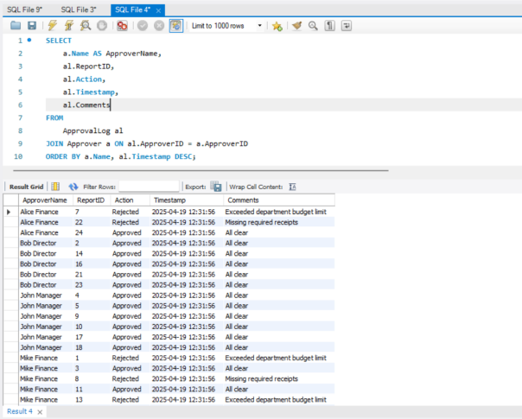

( Query 4 )

## ****Query 5: Employee-wise Summary of Expense Reports and Payment Status****

For each employee, list total number of submitted reports, how many were approved, and how many received payment.

**SQL Query :**

SELECT e.Name AS EmployeeName,

COUNT(er.ReportID) AS TotalReports,

SUM(CASE WHEN er.Status = 'Approved' THEN 1 ELSE 0 END) AS ApprovedReports,

COUNT(p.PaymentID) AS PaymentsMade

FROM Employee e

LEFT JOIN ExpenseReport er ON e.EmployeeID = er.EmployeeID

LEFT JOIN Payment p ON er.ReportID = p.ReportID GROUP BY e.EmployeeID;

**Result and Screenshot:**

|  |  |  |  |
| --- | --- | --- | --- |
| **EmployeeName** | **TotalReports** | **ApprovedReports** | **PaymentsMade** |
| Aarav Sharma | 1 | 0 | 0 |
| Meera Iyer | 1 | 1 | 1 |
| Rohan Mehta | 1 | 1 | 1 |
| Nisha Kulkarni | 1 | 1 | 1 |
| Arjun Reddy | 1 | 1 | 1 |
| Emily Thomas | 1 | 1 | 1 |
| Kunal Malhotra | 1 | 0 | 0 |
| Sneha Joshi | 1 | 0 | 0 |
| Aditya Verma | 1 | 1 | 1 |
| Rachel Mathews | 1 | 1 | 1 |
| Rahul Kapoor | 1 | 1 | 1 |
| Aishwarya Rao | 1 | 1 | 1 |
| Siddharth Jain | 1 | 0 | 0 |
| Neha Bhatt | 1 | 1 | 1 |
| Vishal Bansal | 1 | 0 | 0 |
| Grace Fernandes | 1 | 1 | 1 |
| Manav Thakur | 1 | 1 | 1 |
| Riya Mukherjee | 1 | 1 | 1 |
| Harsh Patel | 1 | 0 | 0 |
| Kavya Sinha | 1 | 1 | 1 |
| James Samuel | 1 | 1 | 1 |
| Ishita Ghosh | 1 | 0 | 0 |
| Varun Das | 1 | 1 | 1 |
| Pooja Pillai | 1 | 1 | 1 |
| Yash Choudhury | 1 | 0 | 0 |

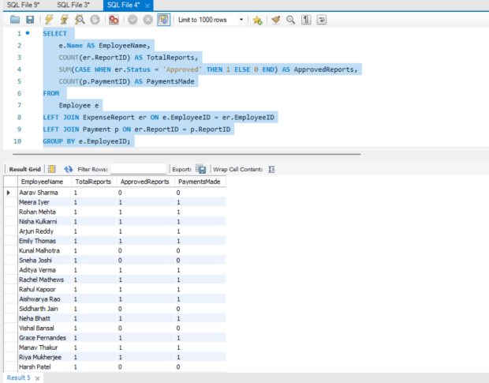

(Query 5 )

**CONCLUSION:**The Corporate Expense Management & Approval System handles employee expense processes from start to finish with an audited structure that simplifies the entire approval cycle. The system establishes seamless expense report tracking alongside hierarchical approval workflows and department budget controls and vendor and payment tracking capabilities thanks to its well-structured relational database. The MySQL Workbench implementation of the database employs primary and foreign key constraints to maintain strong relational integrity while supporting all functional needs and analytical demands. The database design and SQL structure demonstrates practical enterprise requirements while focusing on normalization principles and extended scalability options and administrational access control mechanisms. This project both reinforces essential database design principles and demonstrates practical implementation in a business-critical business area which provides a solid base for building complete enterprise software.

**References:**

*A free database designer for developers and analysts*. (n.d.). <https://www.dbdiagram.io/>

Connolly, T., & Begg, C. (n.d.). *Database Systems:A Practical approach to design, implementation, and management* (SIXth edition). pearson. <https://dl.ebooksworld.ir/motoman/Pearson.Database.Systems.A.Practical.Approach.to.Design.Implementation.and.Management.6th.Global.Edition.www.EBooksWorld.ir.pdfpearson>

Elmasri, R., & B. Navathe, S. (2021). *Fundamentals of database Systems* (7th Edition). Pearson. <https://www.auhd.edu.ye/upfiles/elibrary/Azal2020-01-22-12-28-11-76901.pdf>

*MySQL :: MySQL Documentation*. (n.d.). <https://dev.mysql.com/doc/>